**DESIGN DOCUMENT**

**IDENTIFYING OUR TARGET AUDIENCE**

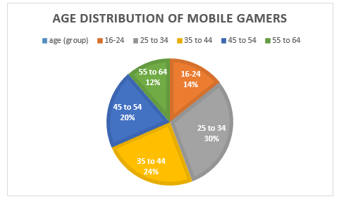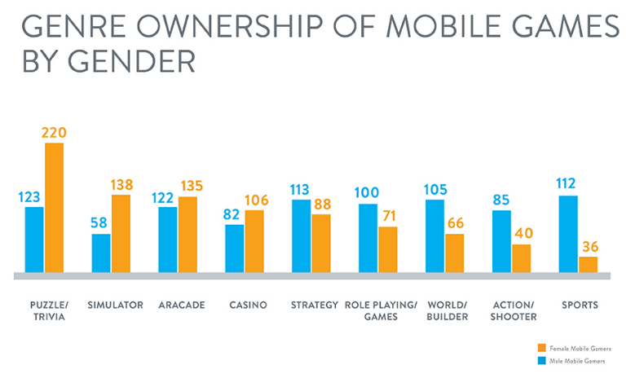Though several reports determine that women play more mobile games than men do, it ultimately depends on the genre and theme of the game that they are playing. As our game would best fall under the ‘Arcade’ genre and involves shooting projectiles, it would most likely be better suited towards a male target audience.

The largest age segment of mobile gamers generally appears to be 25 – 44 year-olds. For casual mobile gamers, habits tend to include playing for short session times during commutes or work breaks. However, as our game encourages competition between two players, it may be beneficial to target a younger range of mobile gamers. As such, the final target audience would best be males aged 16 – 30.

**IDEAS FOR THEMES/GENRES (INCLUDING MOODBOARDS)**

THEME 1 – MEDIEVAL – This theme could include castle battlements to act as walls within the game and either using arrows or cannonballs as the projectile that the players will launch. Targets could be in the form of enemy knights or archery shooting targets.

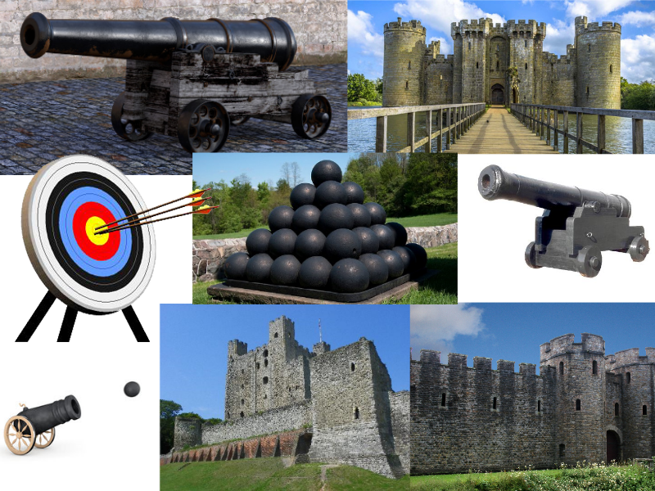

THEME 2 – SCIENCE-FICTION – This theme could include projectiles in the form of lasers that bounce off force fields that can act as the walls of the game. Targets could be small robots or floating holographic targets. Alternatively, the game could be set in an asteroid field in space, where players must shoot at small asteroids or spaceships.

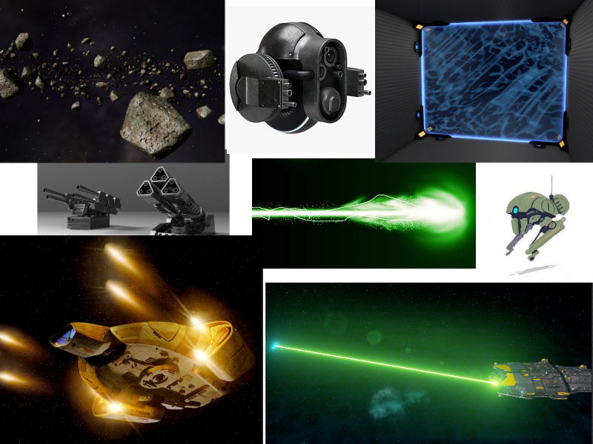

THEME 3 – RETRO – This theme could feature retro-style graphics, glowing neon objects and various particle effects of varying colours.

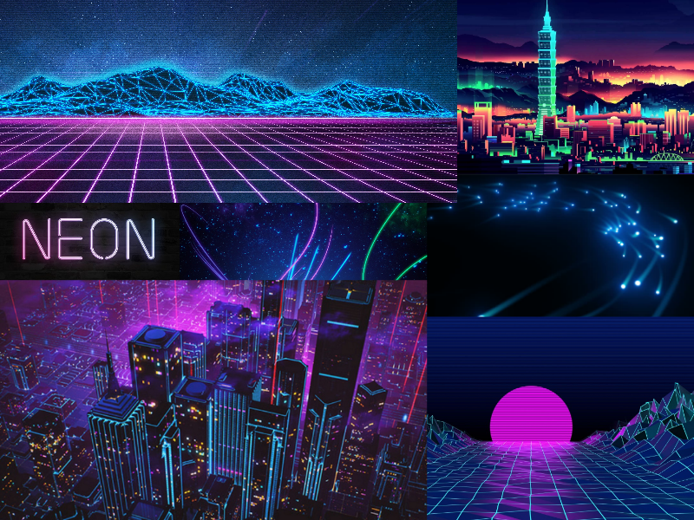

**CHOSEN THEME AND POSSIBLE GAME NAMES**

From these three themes, the Retro theme has been chosen due to the potential of visual appeal we can create out of the glowing and particle effects. Possible names for this game could include:

* Neon Blast